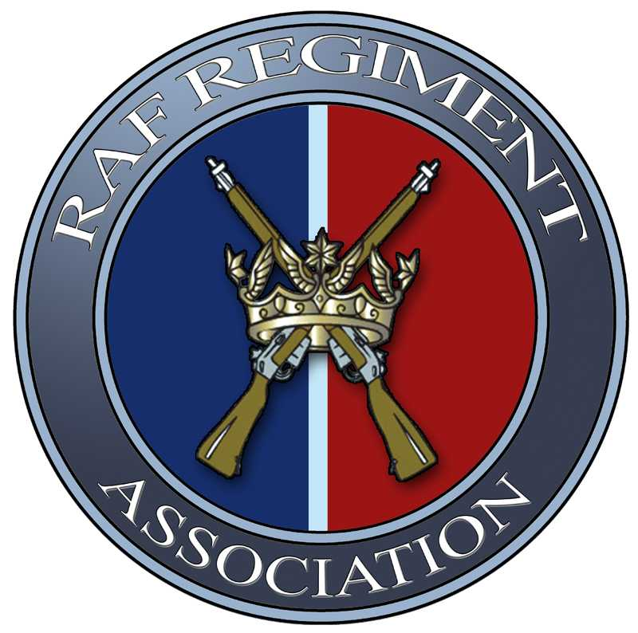

RAF Regiment Association

Data Protection Protocol

Overview
RAF Regiment Association (here after called “ the Assoc”), is fully committed to compliance with the Data Protection Act (1998) and recognises the rights and obligations enforced by the act in the processing of personal data within the organisation. This protocol sets out what Assoc does to meet the requirements of Data Protection legislation.

Introduction
In order to operate efficiently and effectively, the Assoc has to collect and use personal information about members with whom it works. These include former, associates and current personnel of the RAF Regiment. In addition, it may be required by law to collect and use information in order to comply with the requirements of central government and statuary regulations.
The Assoc regards the lawful and correct handling of personal information as very important to its successful operations and to maintaining confidence between the Assoc and those with whom it provides its services.

Scope
This protocol covers personal data held electronically by the Assoc on central (intranet) IT systems, and officially approved PC’s, in addition to data stored in paper files. Personal Data is defined as any information from which a living individual can be identified.
The protocol applies to all Assoc members, elected and co-opted officials, and any other third party who is authorised to process information on behalf of the National Management committee, (NMC), of the Assoc.

Aim
The aim of this protocol is to ensure that the Assoc treats personal information lawfully and correctly in accordance with the Data Protection Act 1998 regardless of the format in which it is stored and collected.

Owner
The protocol is owned by the National Secretary of the Assoc.
The Assoc's current Data Protection Officer is:
- Mr Francis Xavier – National Secretary natsec@rafregt.org.uk
The following personnel can also assist with any Data Protection issues:
- Mr Peter Lawrence – Chairman peterlawrence@ntlworld.com
- Mr Gordon Diffey - Assoc Webmaster Gordon@the-internet-marketer.co.uk

Principles
The Assoc is fully committed to the five main principles of the Data Protection Act (1998).
When collecting and processing personal data the following principles will be applied:

(1) Personal data shall be processed fairly, lawfully and, in particular, shall not be processed unless specific Assoc requirements are met

The Assoc will ensure that the collection and processing of information is not excessive and that it is appropriate to fulfil the operational needs of the organisation or to comply with any legal requirements.

(2) Personal data shall be obtained only for one or more specified and lawful purposes, and shall not be further processed in any manner incompatible with that purpose or those purposes

The Assoc will ensure that when information is collected, on forms or by other methods, specific advice is given as to the purpose(s) of gathering and using the information.

(3) Personal data shall be adequate, relevant and not excessive in relation to the purpose or purposes for which they are processed

The Assoc will ensure the quality and accuracy of any information used and that any information held is factually relevant to the area of work concerned.

(4) Personal data shall be accurate and, where necessary, kept up to date

The Assoc will ensure that any personal information is not held for longer than required and, by applying checks to determine the length of time information is held, make sure that personal data is destroyed in an appropriate manner once the retention period has expired.

(5) Personal data shall be processed in accordance with the rights of data subjects under the Act

The Assoc will also ensure that:
- Any strategic partners or third parties (service providers) who have access to or share our data follow our policies and procedures and are covered by either a data sharing agreement or outsourcing contract which allows them to lawfully act on our behalf as data processors.
- The NMC of the Assoc will provide resources as required to oversee data protection issues across the organisation.
- All Assoc personnel (including contractors) involved in the collection and processing of personal data are aware of their legal responsibilities to provide adequate protection of personal information and safeguard against unlawful disclosure.

Contact us
Data Protection Officer
RAF Regiment Association
Force Protection Headquarters
Royal Air Force Honington
Bury St Edmunds
Suffolk
IP31 1EE

RAF Regt Assoc/NMC- Mar 2015

